Password Protecting a Doc File

- Open the Word File, click “FILE” on the left top corner.
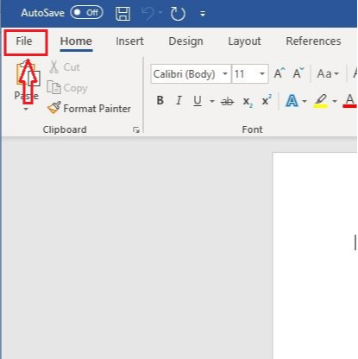

- Click “Info”
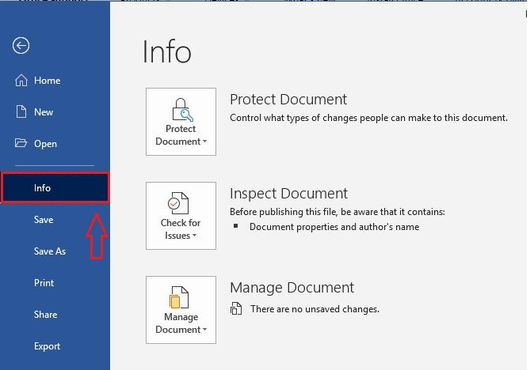

- Click “Protect Document”. You will get a drop down as per the below screen shot. In that click the “Encrypt with password”.
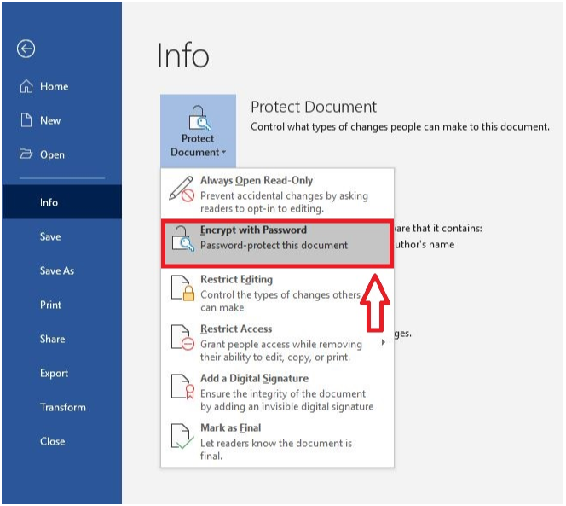

- Enter password and click “OK”
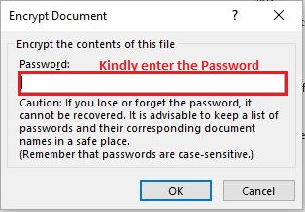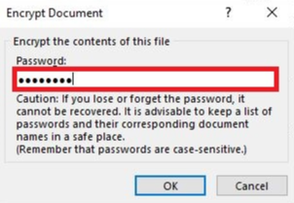

- Re-enter the Password and click OK.

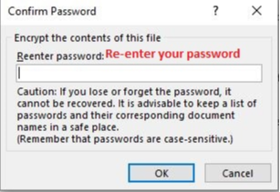

- Your word document is now Password Protected.
